**Assignment**

**Spring Data Jpa with Hibernate Part-1**

*Date-11/03/2021*

Q1)Create an Employee Entity which contains following fields

Name

Id

Age

Location

Answer-

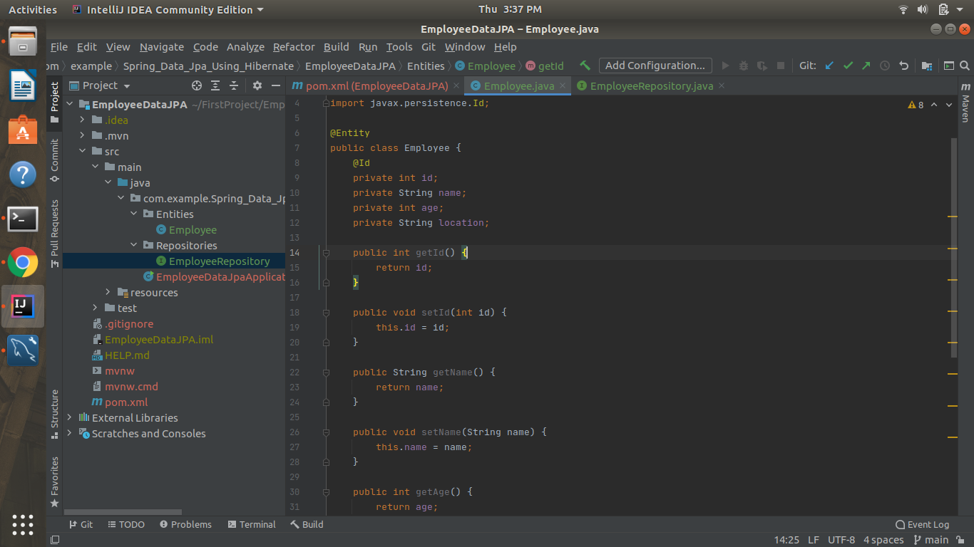

Q2)Set up EmployeeRepository with Spring Data JPA

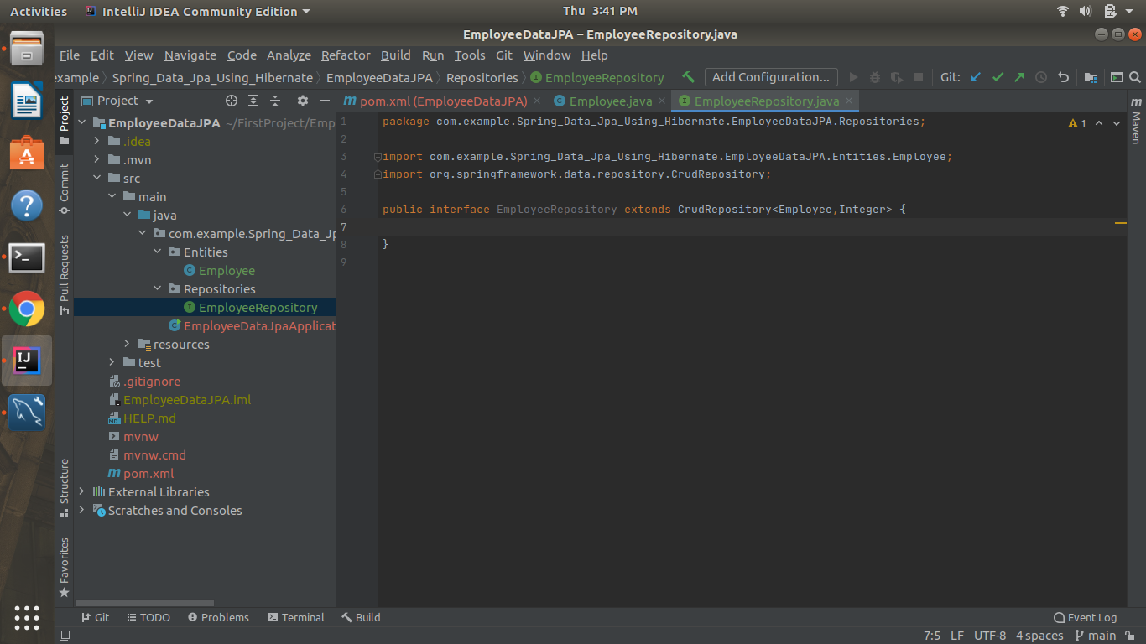

Q3)Perform Create Operation on Entity using Spring Data JPA

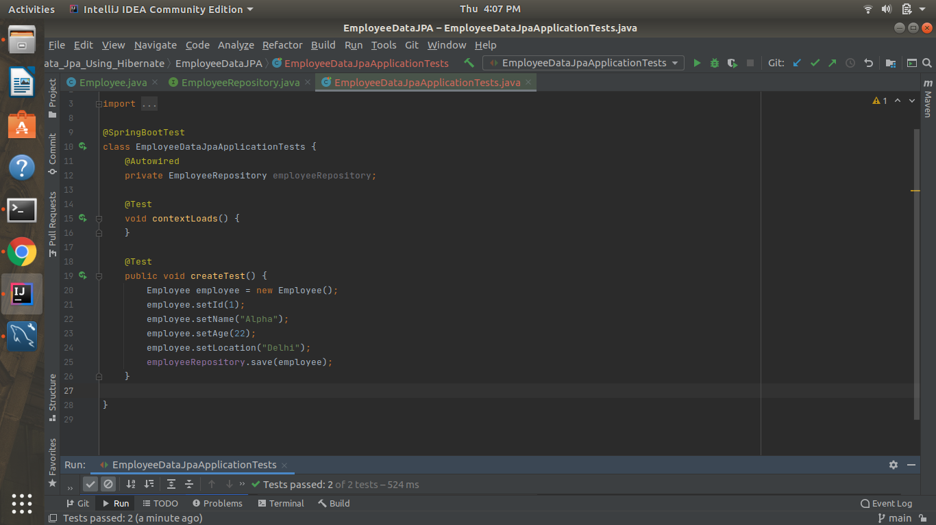

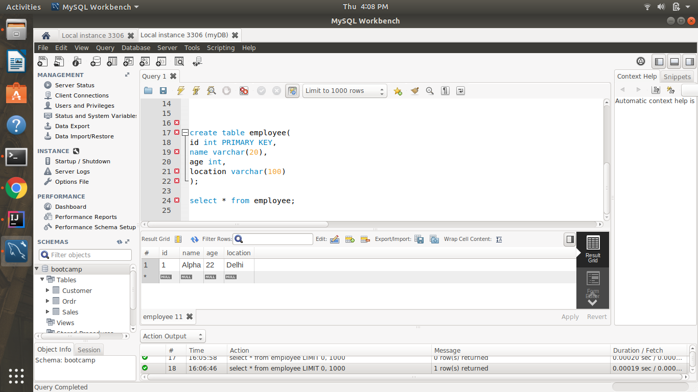

Q4) Perform Update Operation on Entity using Spring Data JPA

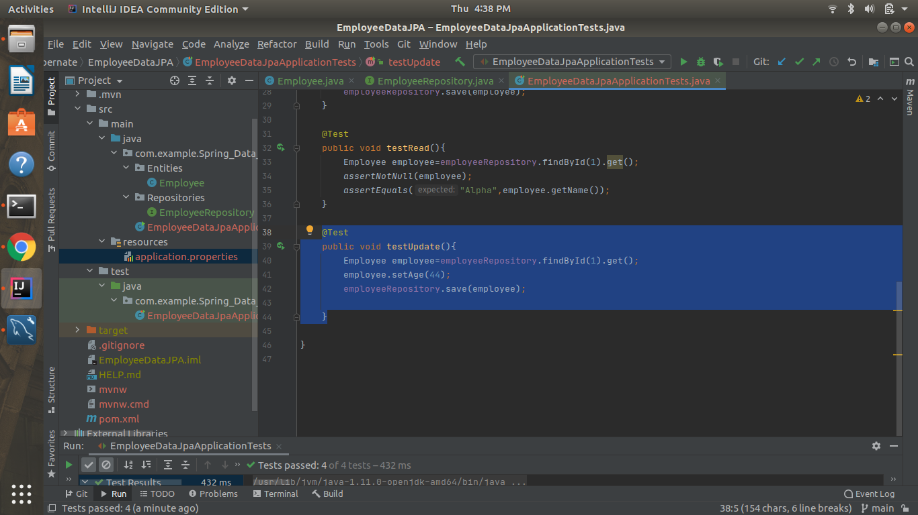

Age has been updated

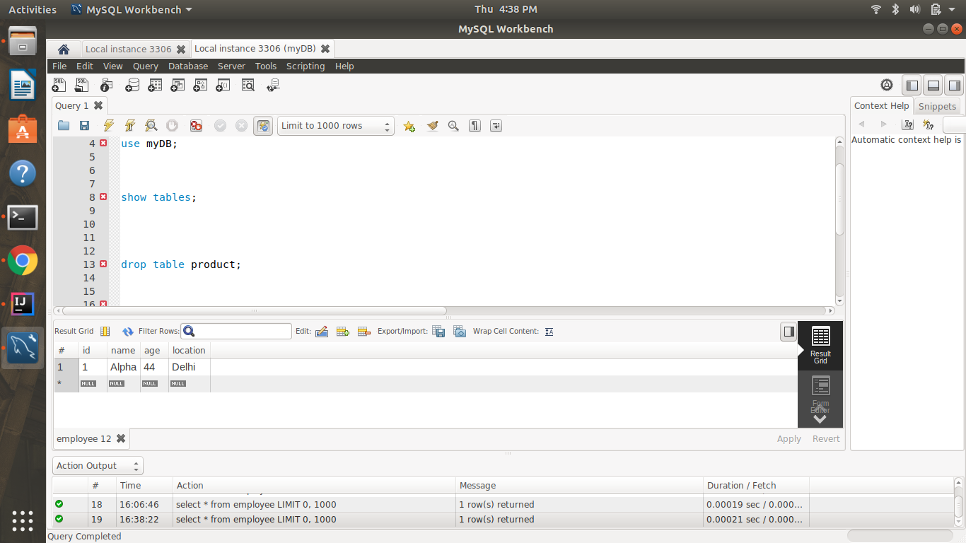

Q5)Perform Delete Operation on Entity using Spring Data JPA

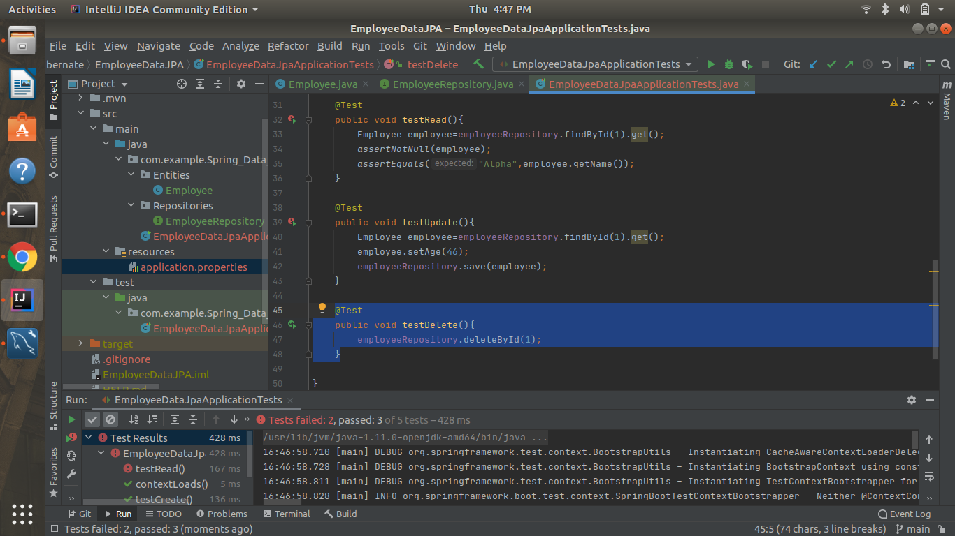

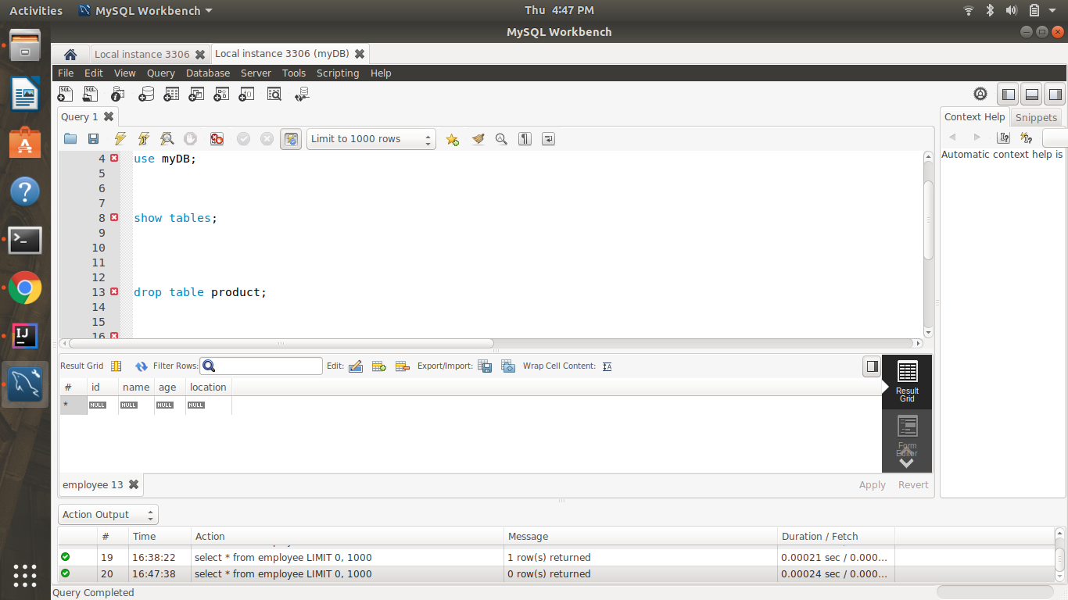

Q5) Perform Read Operation on Entity using Spring Data JPA

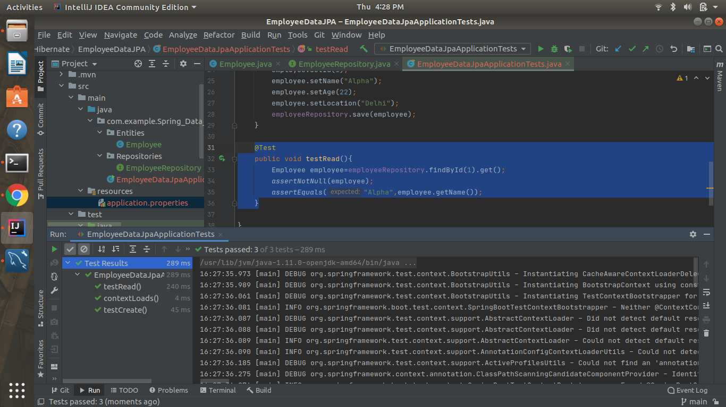

Q6)Get the total count of the number of Employees

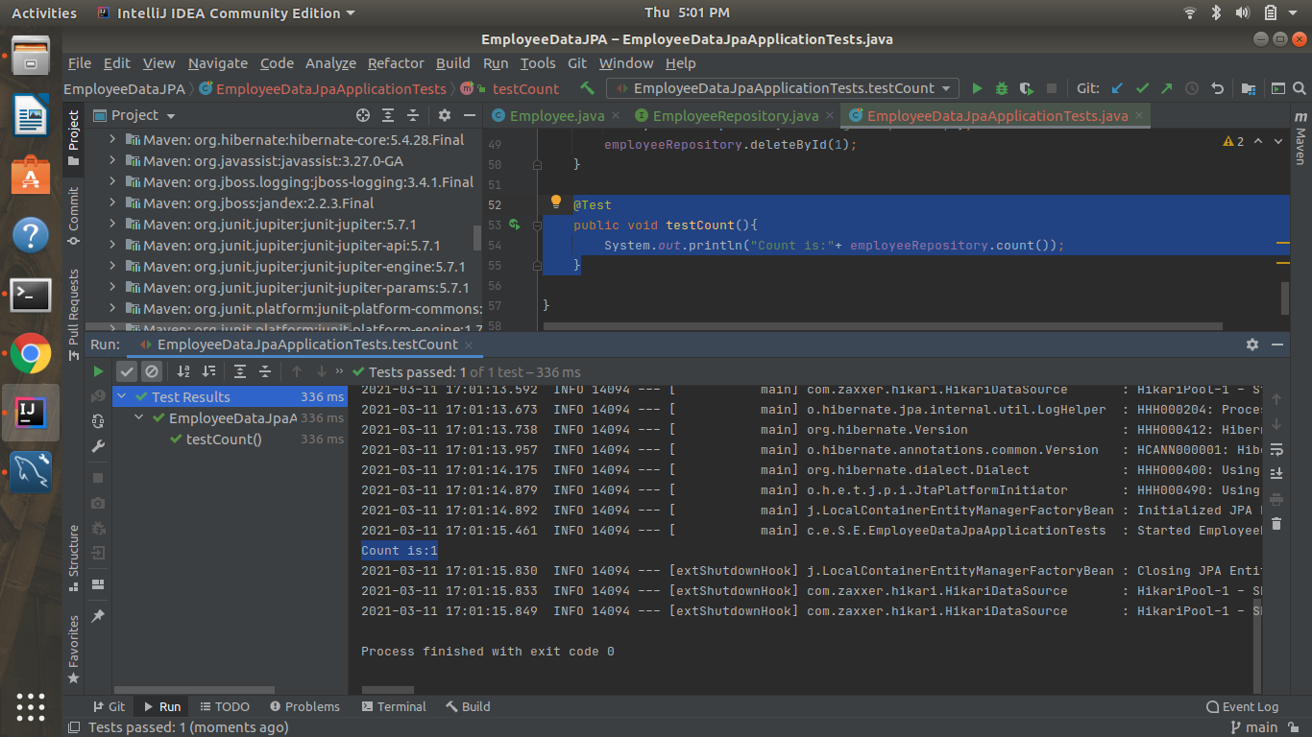

Q7)Implement Pagination and Sorting on the bases of Employee Age

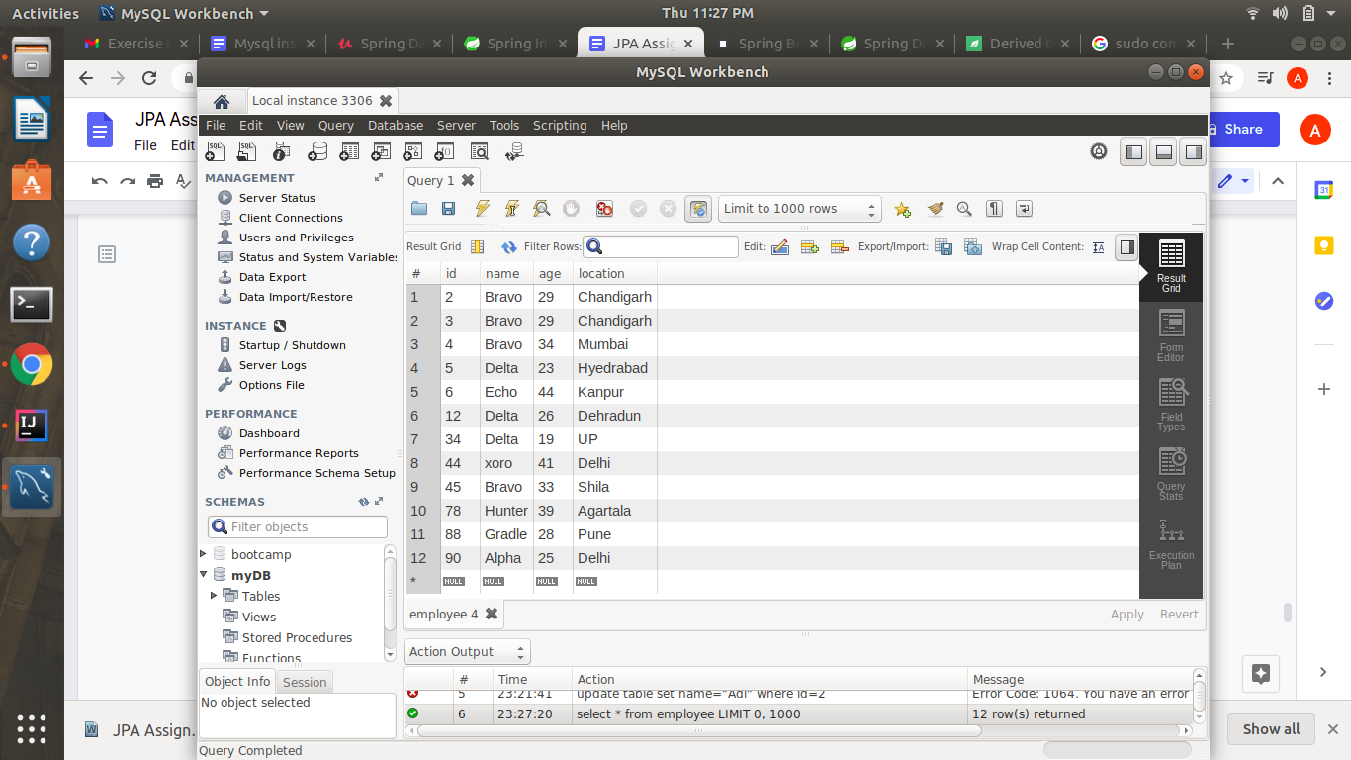

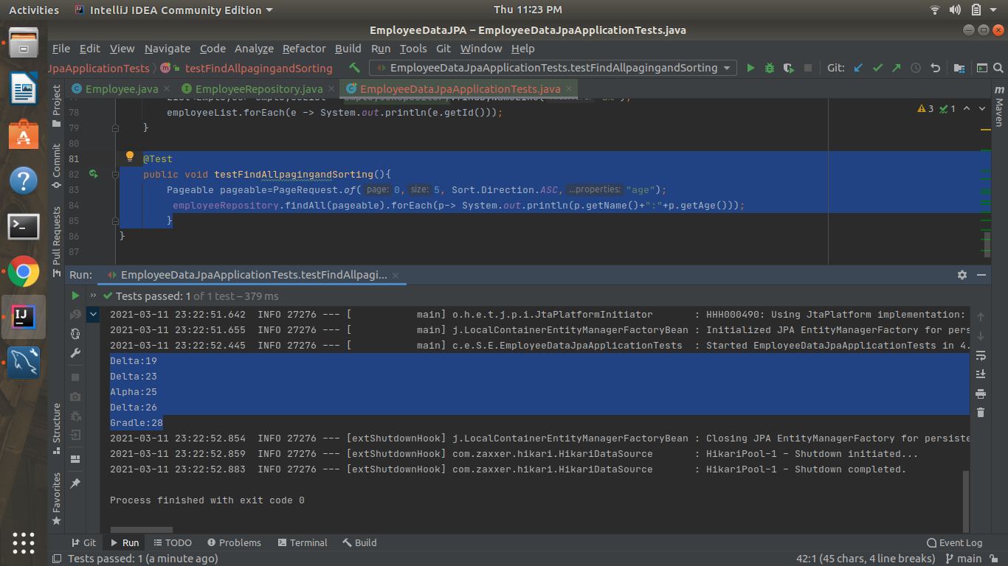

Q8) Create and use finder to find Employee by Name

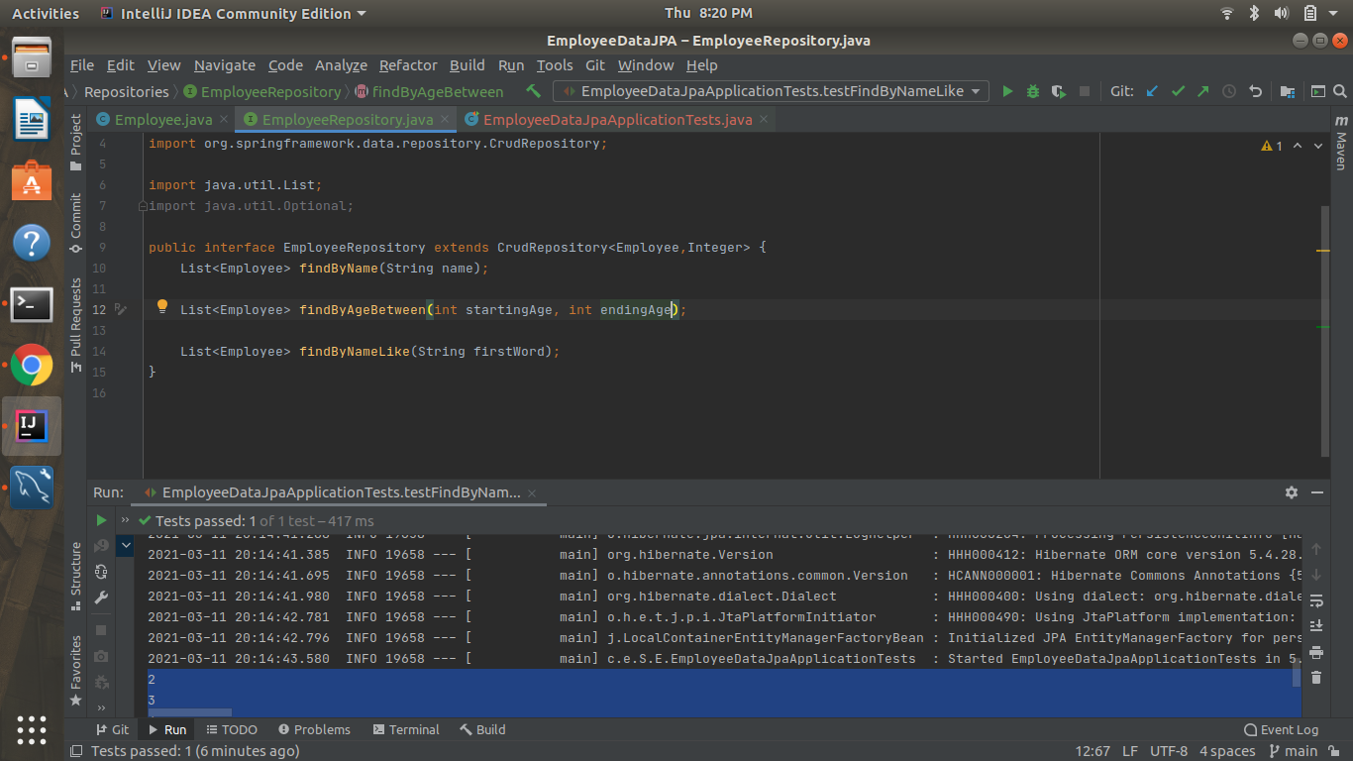



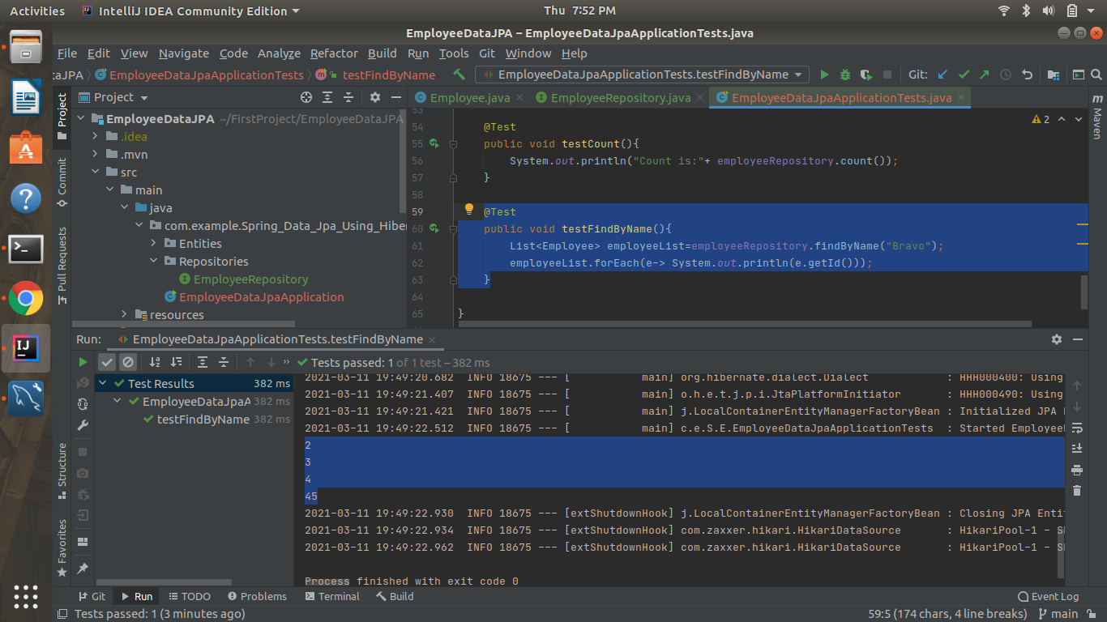

Q9)Create and use finder to find Employees starting with B character

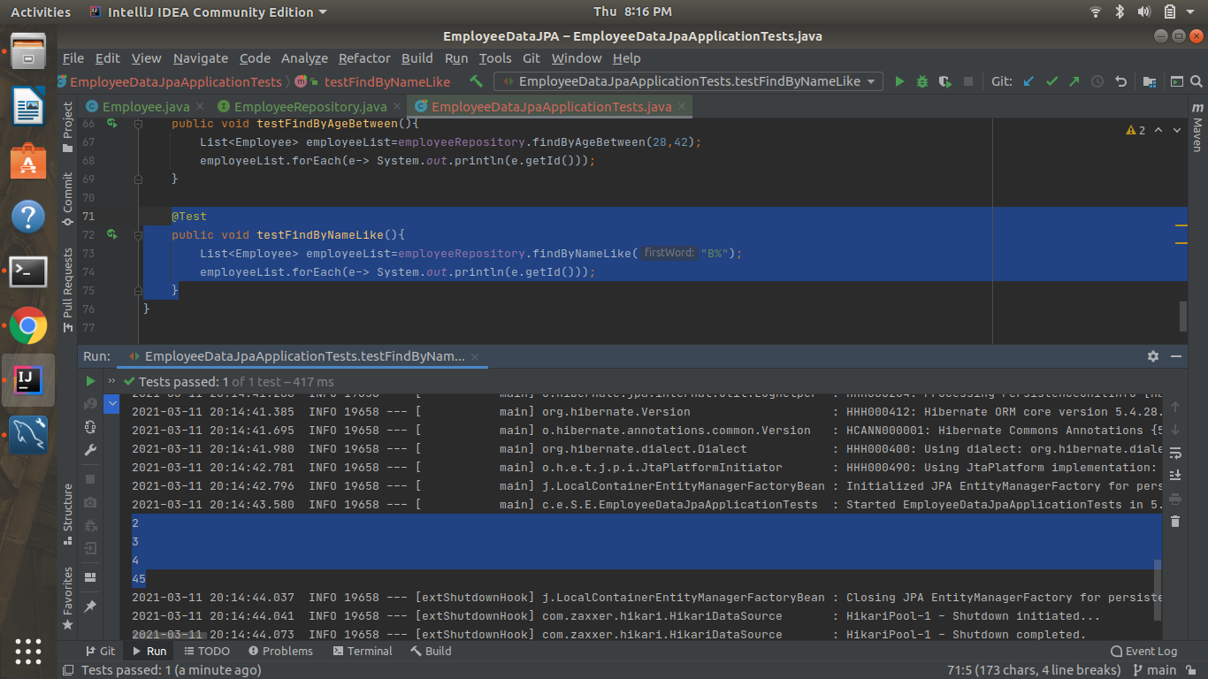

Q10)Create and use finder to find Employees Between the age of 28 to 42



